Microsoft Office User

SANJALIKA WATER PARK NAIROBI KENYA

SANJALIKA WATER PARK

ACKNOWLEDGEMENT 2

SYNOPSIS & PROJECT ANALYSIS 3

DATA FLOW DIAGRAMS LEVEL – 0 AND LEVEL-1. 4

LEVEL- 0. 4

DFD Level-1 5

FLOWCHART DIAGRAM 6

PROCESS DIAGRAM 8

USER’s GUIDE 9

Navigation bar 10

PAGES 11

The homepage 11

Gallery page 14

Contact us page 16

Send message form 17

The Footer 18

DEVELOPERS GUIDE 28

Index html code 28

Index html style css 35

Script file 46

Email html 47

Email css 48

# ACKNOWLEDGEMENT

Doing the project was of a great experience of progress to me throughout the four week time duration I was given. Dealing with it was a necessary to see where my progress was taking me while keeping time with every step I take to finish the project. I would like to acknowledge for all the possible information of the data I retrieved for my website and the tedious effort for coming up with the entire code as well as the flow charts and the data diagrams. I would also like to give my gratitude to Mr. Keneth Mathiu for his advice and guidance from our consultations from him. We also like to thank the entire EduLink Administration for giving us the opportunity to present my latest accomplishment with great confidence and moral. I also acknowledge, as student, how this project has taught me the importance of Time Essential and Communication to get more information as I used those tools in my progress towards completing it.

**Student name : SALIEM TSEGAY OQUBALDET**

**ID NO : STUDENT 2109761**

## SYNOPSIS & PROJECT ANALYSIS

Sanjalika Water Park is a website that deals with water parks that we get used to have fun. Our websites bring the happiness and enjoyment of our customers.

Our website **appeal to families who want quality recreation time in an extremely safe environment**. After all, waterparks are the safest place to have fun in the water compared to oceans, rivers, lakes and even swimming pools. Thus, parents can feel confident about going to a waterpark with their kids and we did our best for customers to register online purposing on saving their money and worthwhile time.

* Our website also provides the prices and the features of our park services so that our customers can see the quality of our classes. Our website is COST-EFFECTIVE. When it comes to cost to build and maintain water park rides park rides, the costs for a water park are significantly less expensive than the costs for another parks. ...
* GUESTS WILL EXTEND THEIR VISIT.

I have been searching many more information so as to give best and advanced options to meet your needs. While in the process of gathering information, I learned of the different brands and the value of the park apparatus within each of them. My website has ensured the details of each available park services for esteemed customers who access my website.

DIAGRAMS

### 

### DATA FLOW DIAGRAMS LEVEL – 0 AND LEVEL-1.

#### LEVEL- 0.

manager

website

Customer

login update

confirmation confirmation

### DFD Level-1

Register

online

1.

Customer

register

Payment mode

Acknowledgement customer and registry information

2.

Manager

Confirmation

Register information

Register history

Sanjalika Water Park

Register device

3.

Confirmation

mail

### FLOWCHART DIAGRAM

Want to see all service classes

Look in to gallery link

YES

Look all the classes and services

NO

Browse service class

Found suitable service class

NO

Search for another service class

YES

Search for chosen service class

Look for class feature and price

B

B

Found class suitable to register

NO

Look for another class

YES

Enter email to register online

Press enter email

### PROCESS DIAGRAM

ANALYSIS PHASE DESIGN PHASE DEPLOYMENT

HTML DESIGNS

WEBSITE MANUAL

INTRODUCTORY DISCUSSIONS

CSS DESIGN

DEPLOY WEBSITE TO USERS

REQUIRMENT ANALYSIS

JAVA SCRIPT

PROPOSAL

PRESENT HOW THE WEBSITE OPERATES

CLIENT AGREES

AGREE ON SCHENDULE

FILLING DATA TO WEBSITE

NO YES NO YES

FULL DATA OUT LINE OF WEBSITE DIAGRAM

#### USER’s GUIDE

At first, I designed the *index* page in a way that I want so that I could use the same features for the home page, the services page, the gallery page, the contact page. The index page has pages for different services given by the website. Some of the pages include the home page, the services page, gallery page, contact page. The code for the index html is as follows.

#### Navigation bar

This is how the header page looks like. It consists of a logo in the name of the website and its different categories and the navigation to the home, services page, gallery page and contact page.

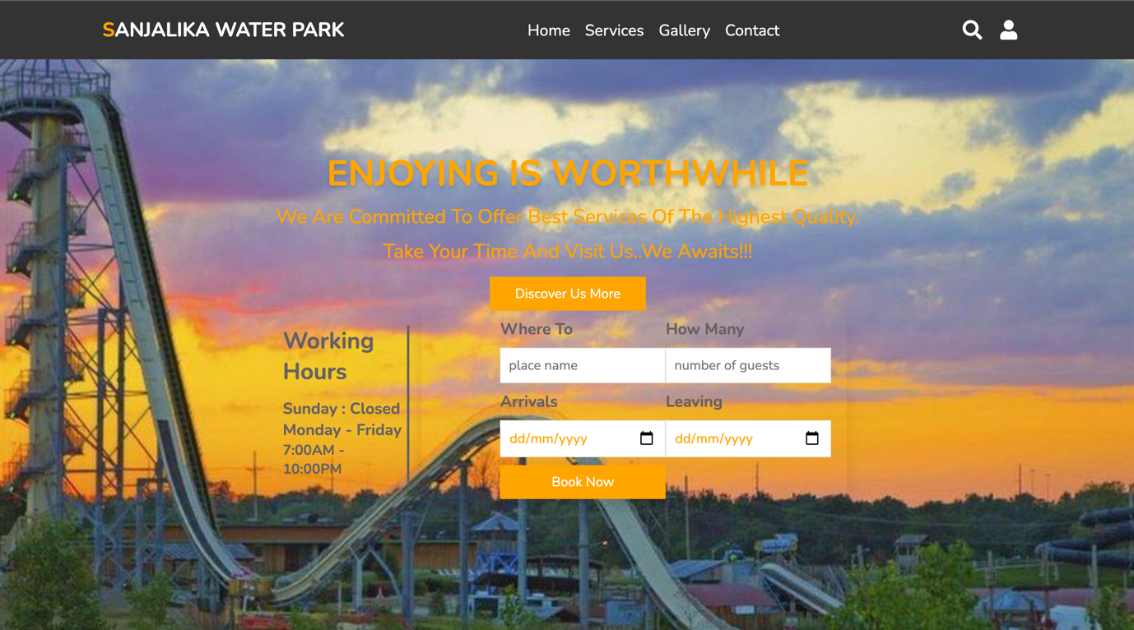

##### PAGES

##### The homepage

The home page is meant to contain contents for the navigation link, the logo, the discovering link and booking link. It has the header section with the logo and navigation bar, the part of the body that is created with suitable sections with the footer that has the Facebook, Instagram, twitter as well as youtube contact. At front it has a search logo. This is how it looks like;

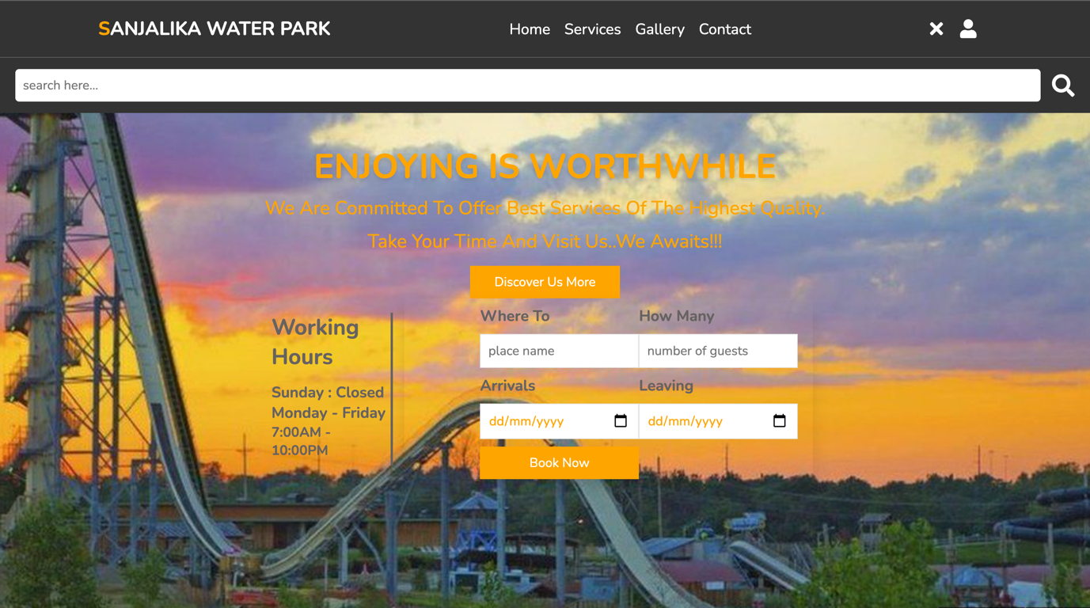

And this is the registering table that comes after clicking the contact logo.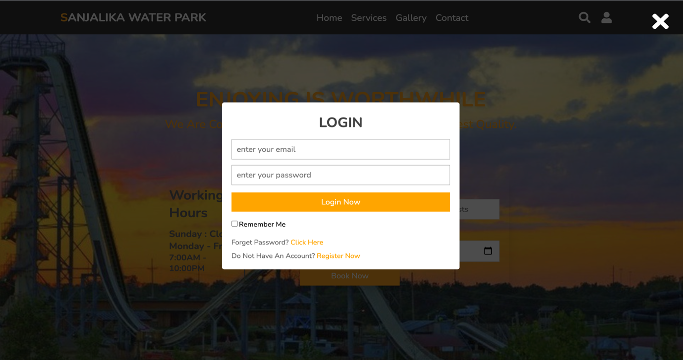Services

This is the services page. It includes all the main and extra services that we give and the facilities our company get used.

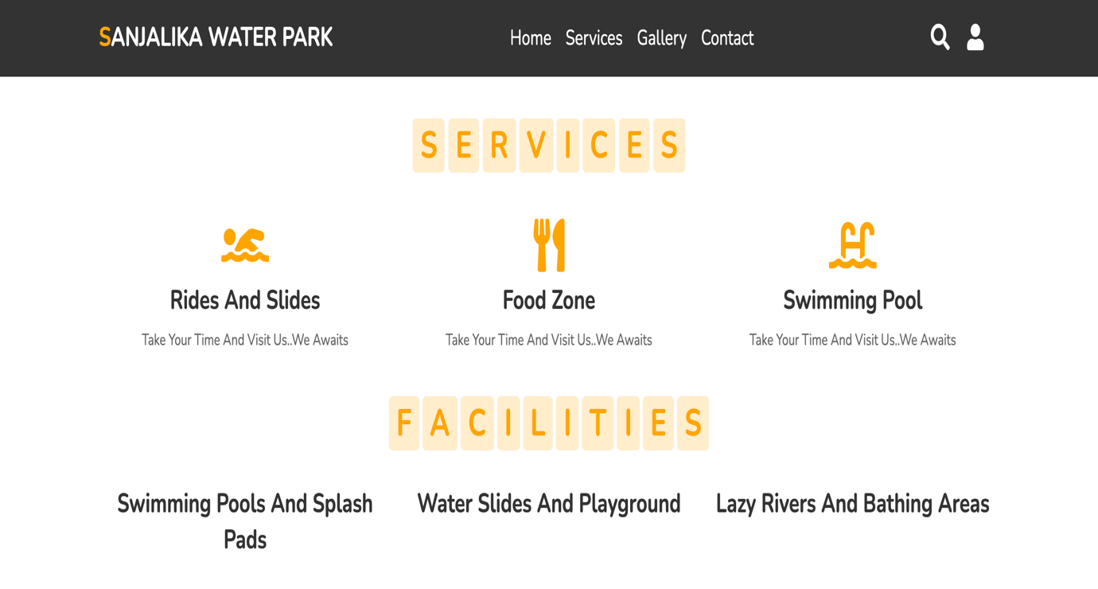

##### Gallery page

This a page where it contains the photos of our company for the all services we give including the other branches.

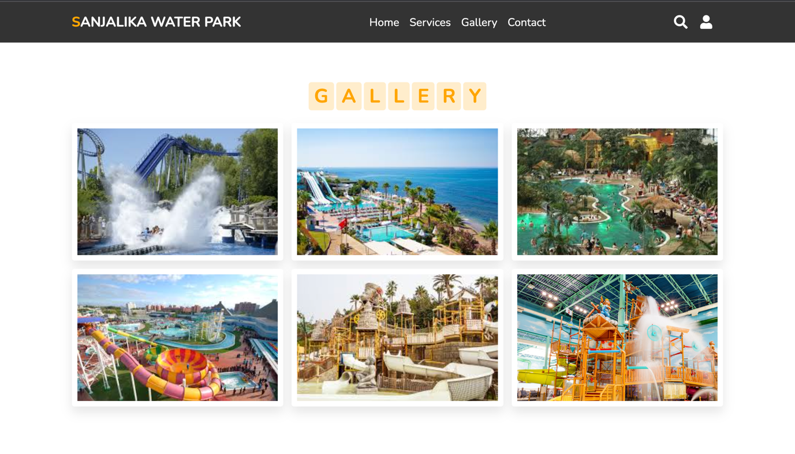

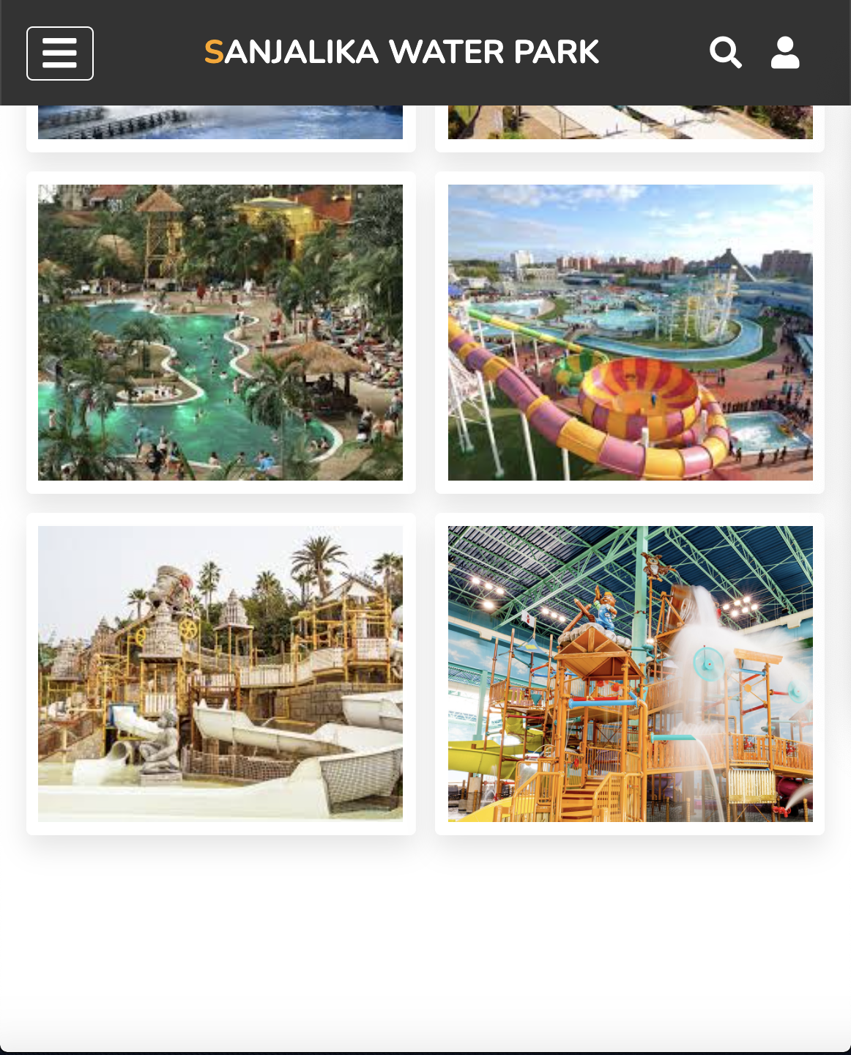

You can choose and see more amazing places throughout online by just clicking the ‘see more’ link.

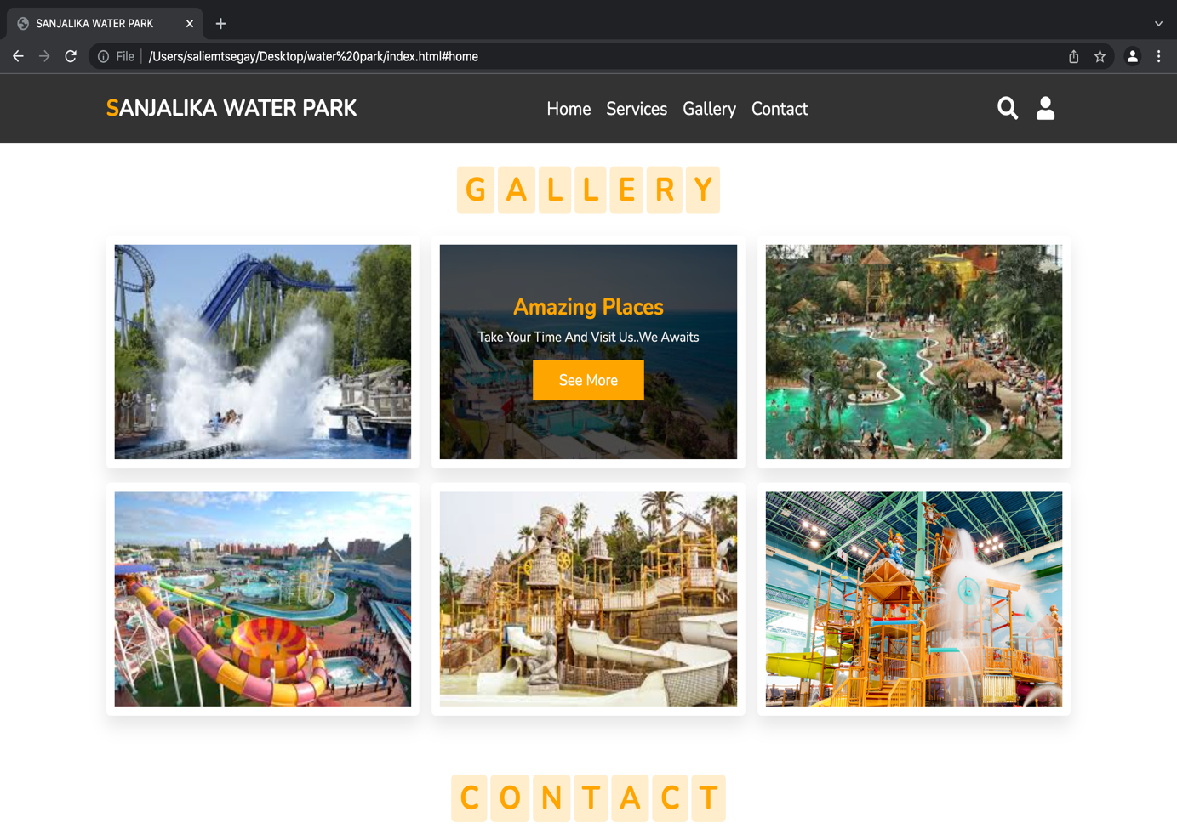

##### Contact us page

This is a page where it contains contact us page including the geolocation of our main company and the send message link where you can send if you have any doubt as well as the downloading link. This has two options:

1.downloading as pdf file

2.downloading as document file

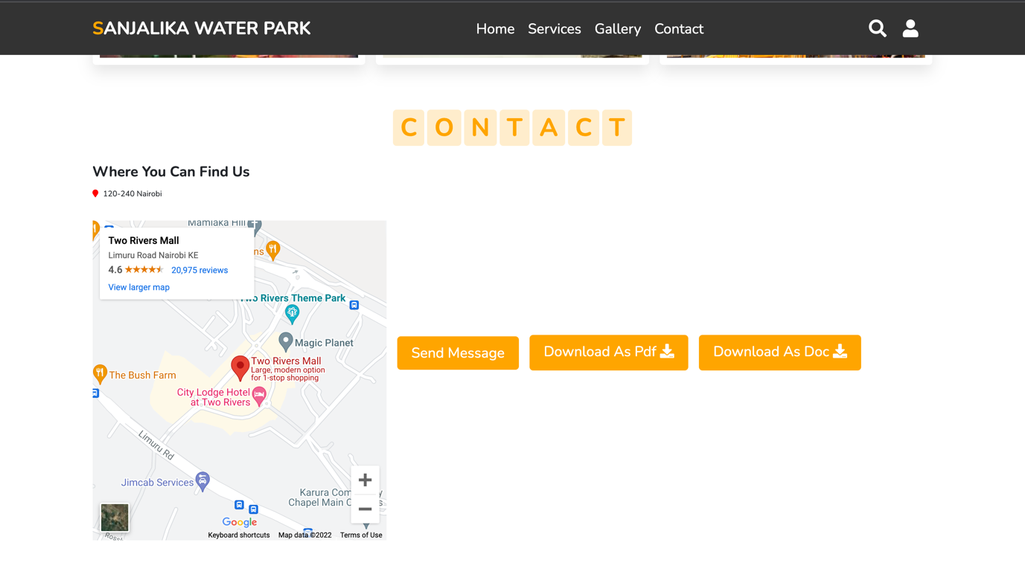

##### Send message form

This is the page where you send your message.

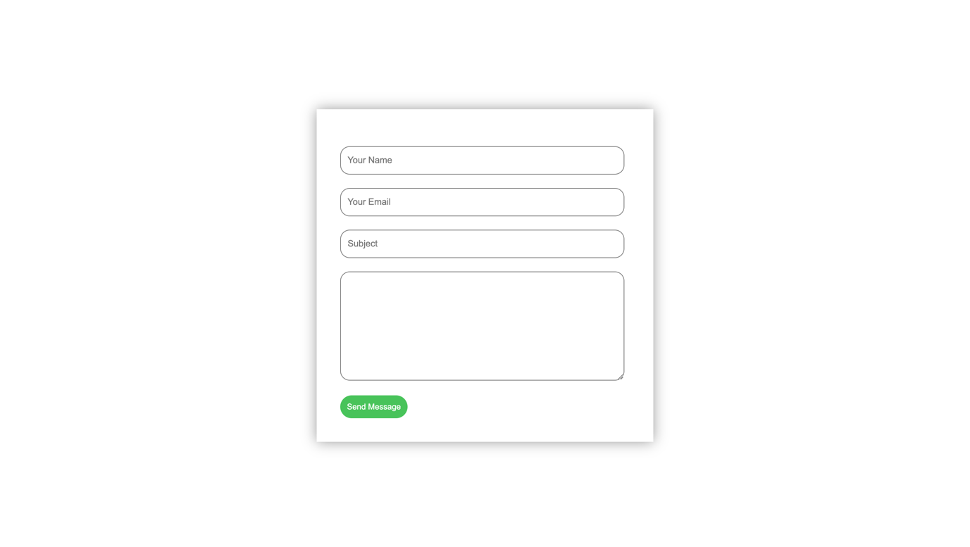

##### The Footer

The footer has the about us, park information, branch locations other than our main park the quick links and pages where you can follow us and four other social media links. And at the bottom it shows by whom the website was created.

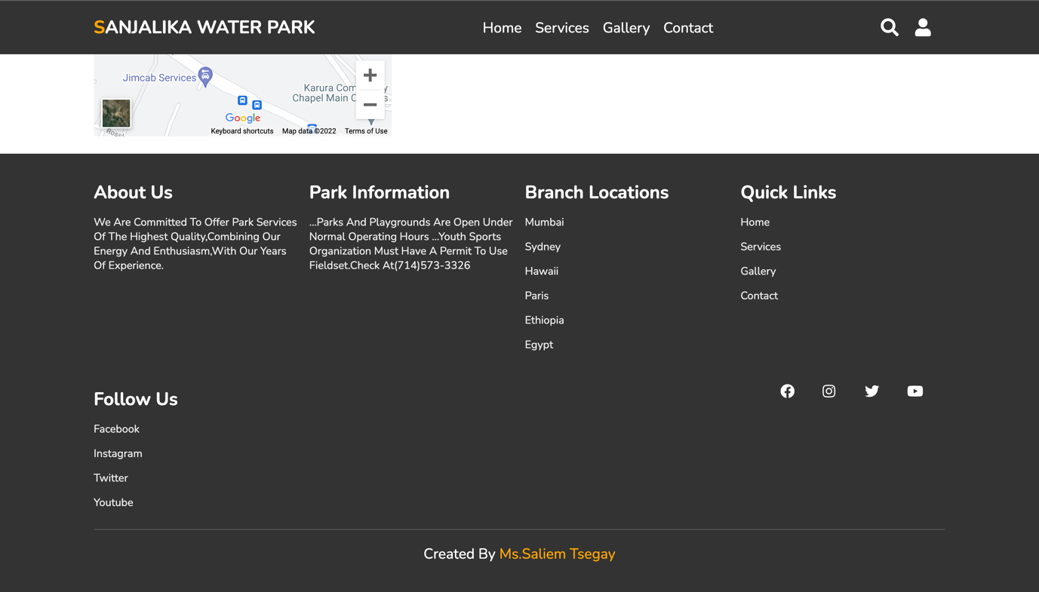

This is how it looks in table form.

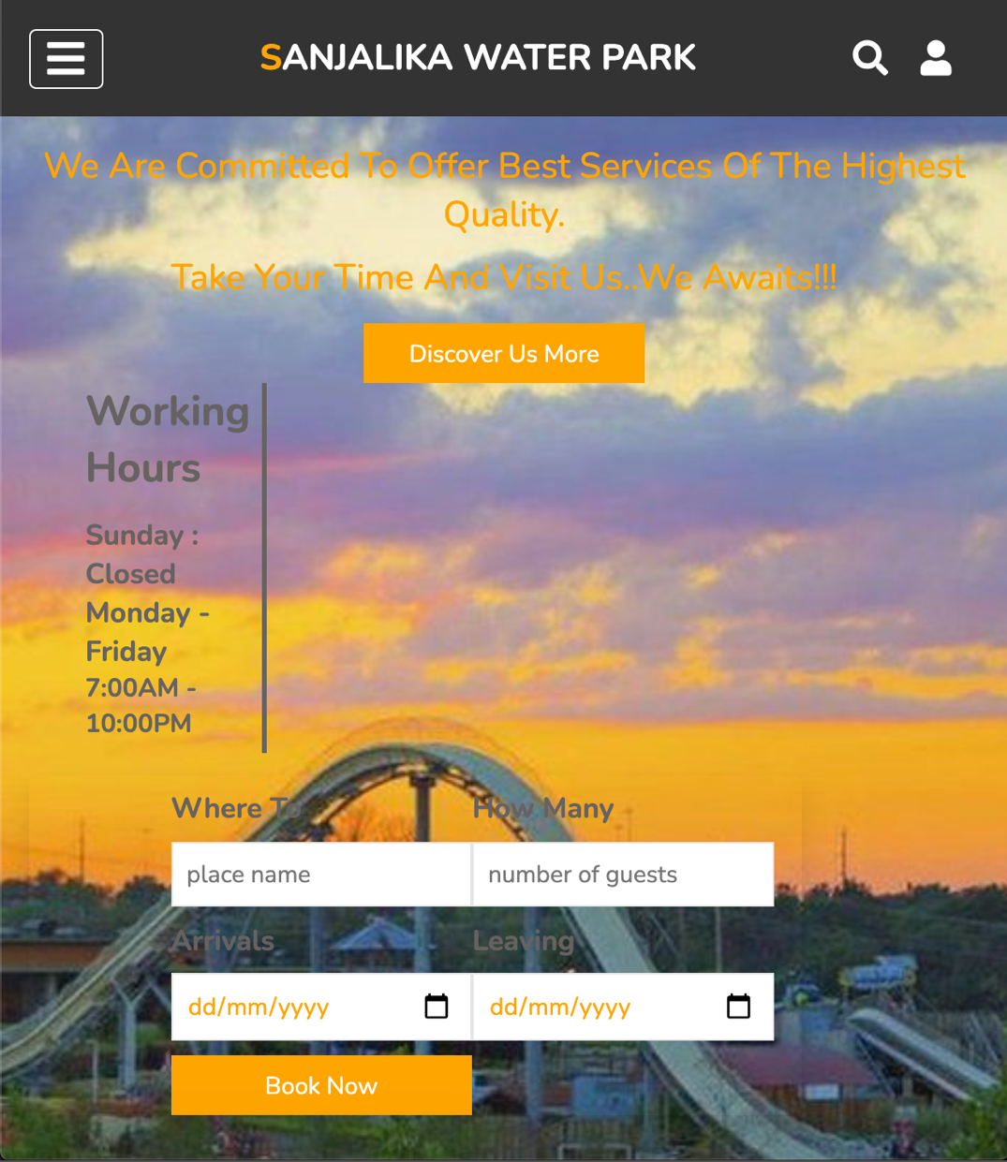

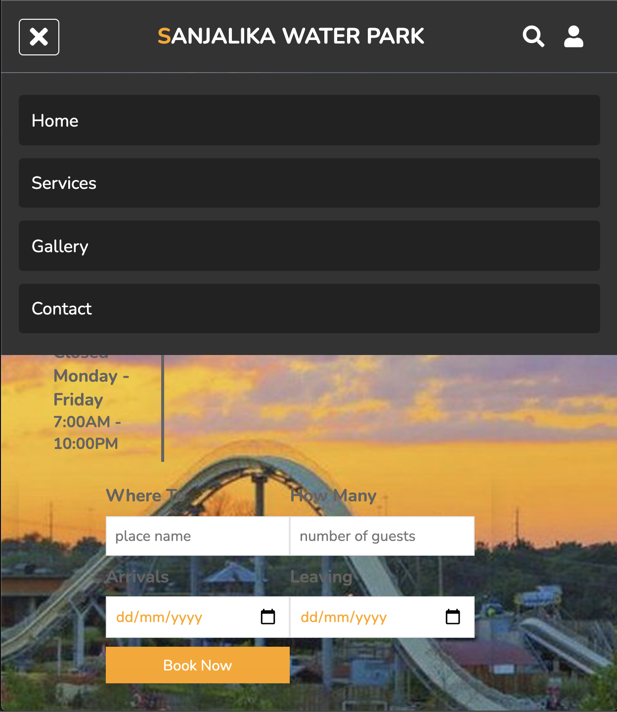

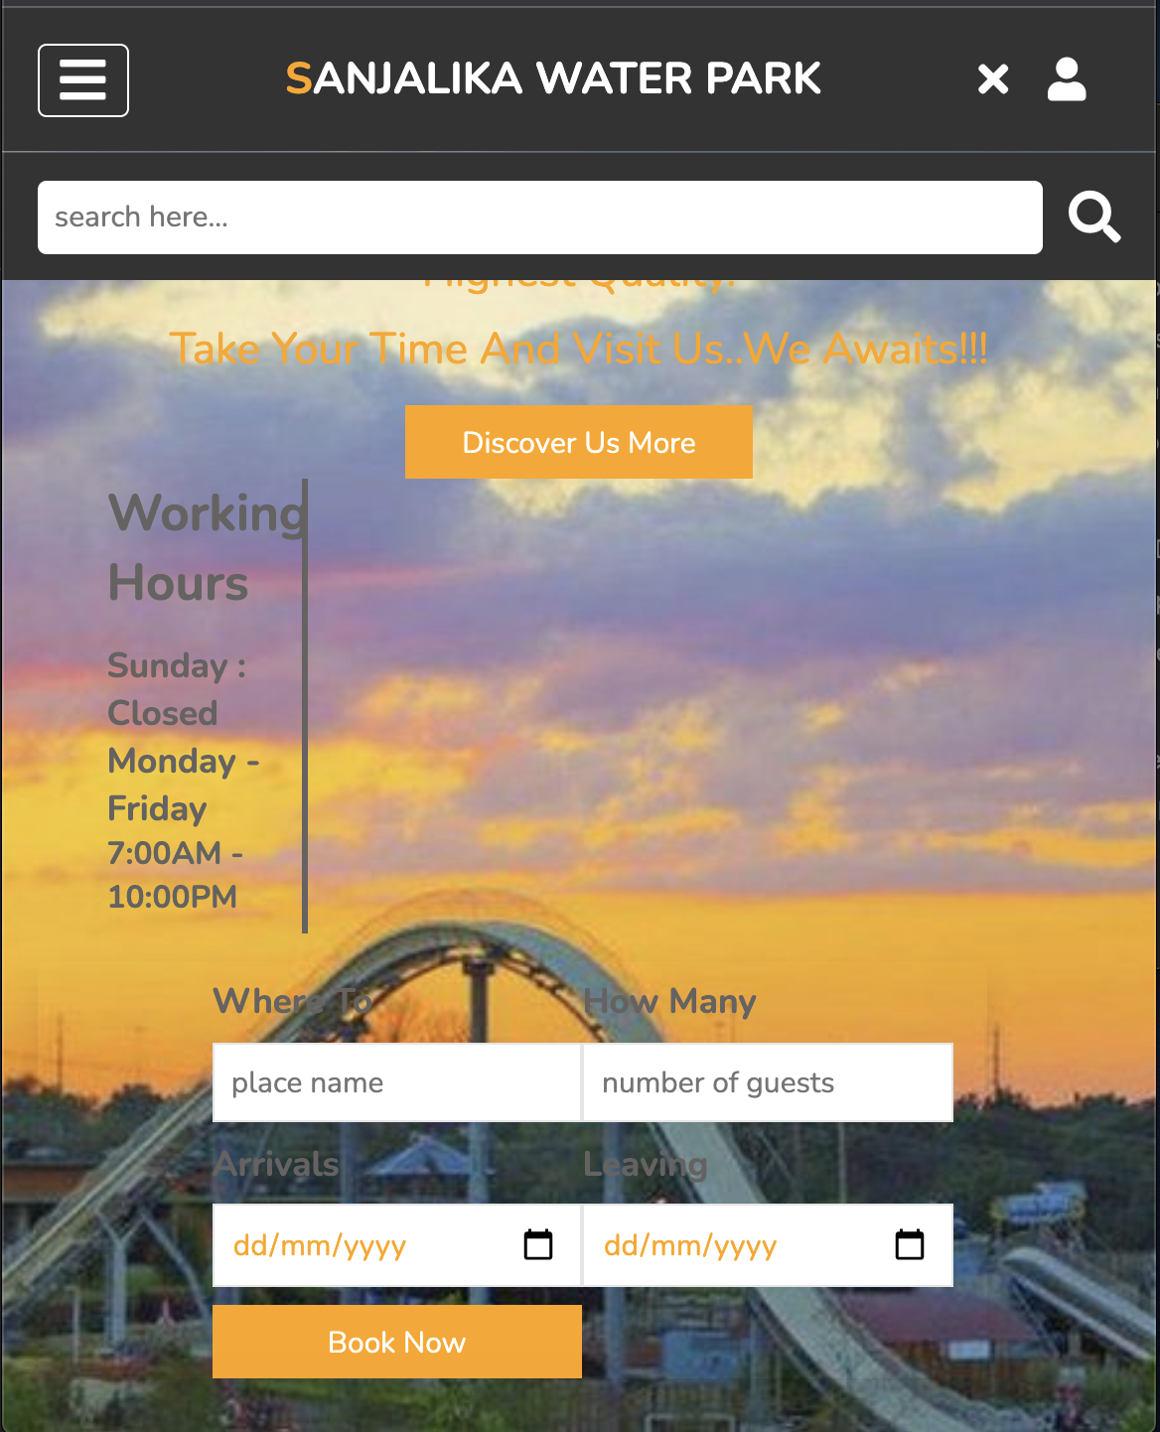

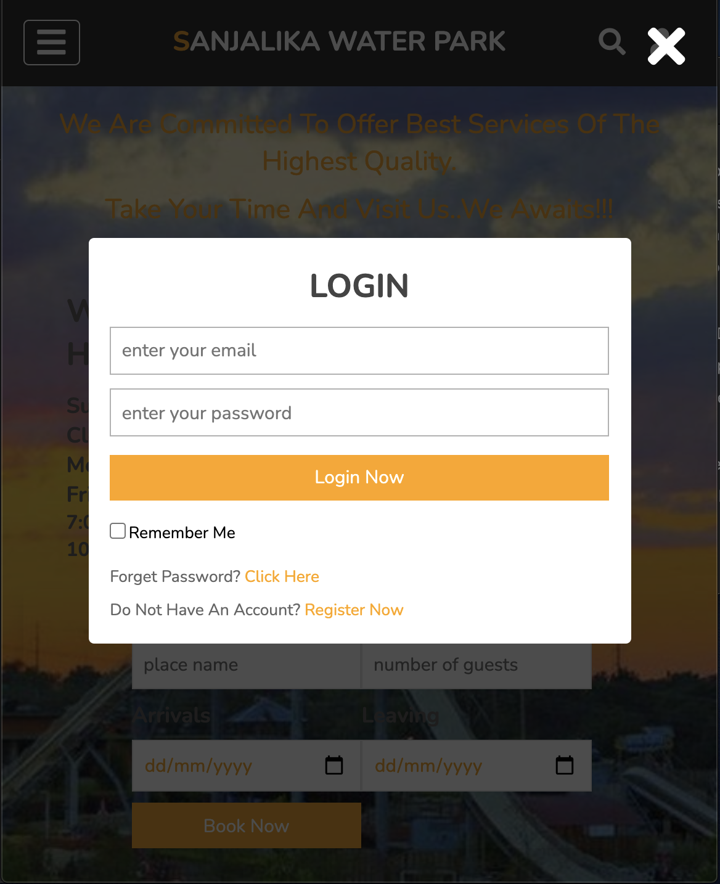

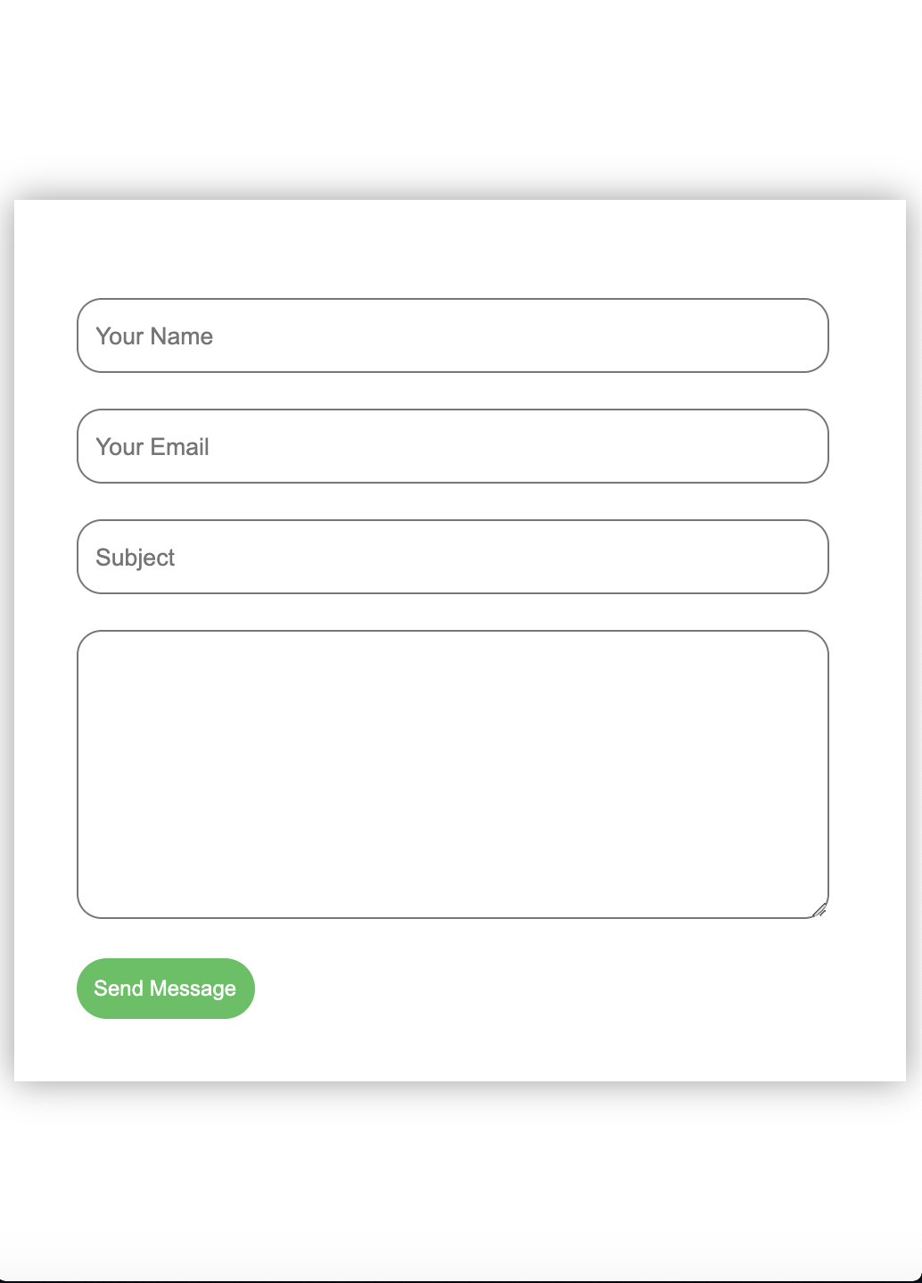

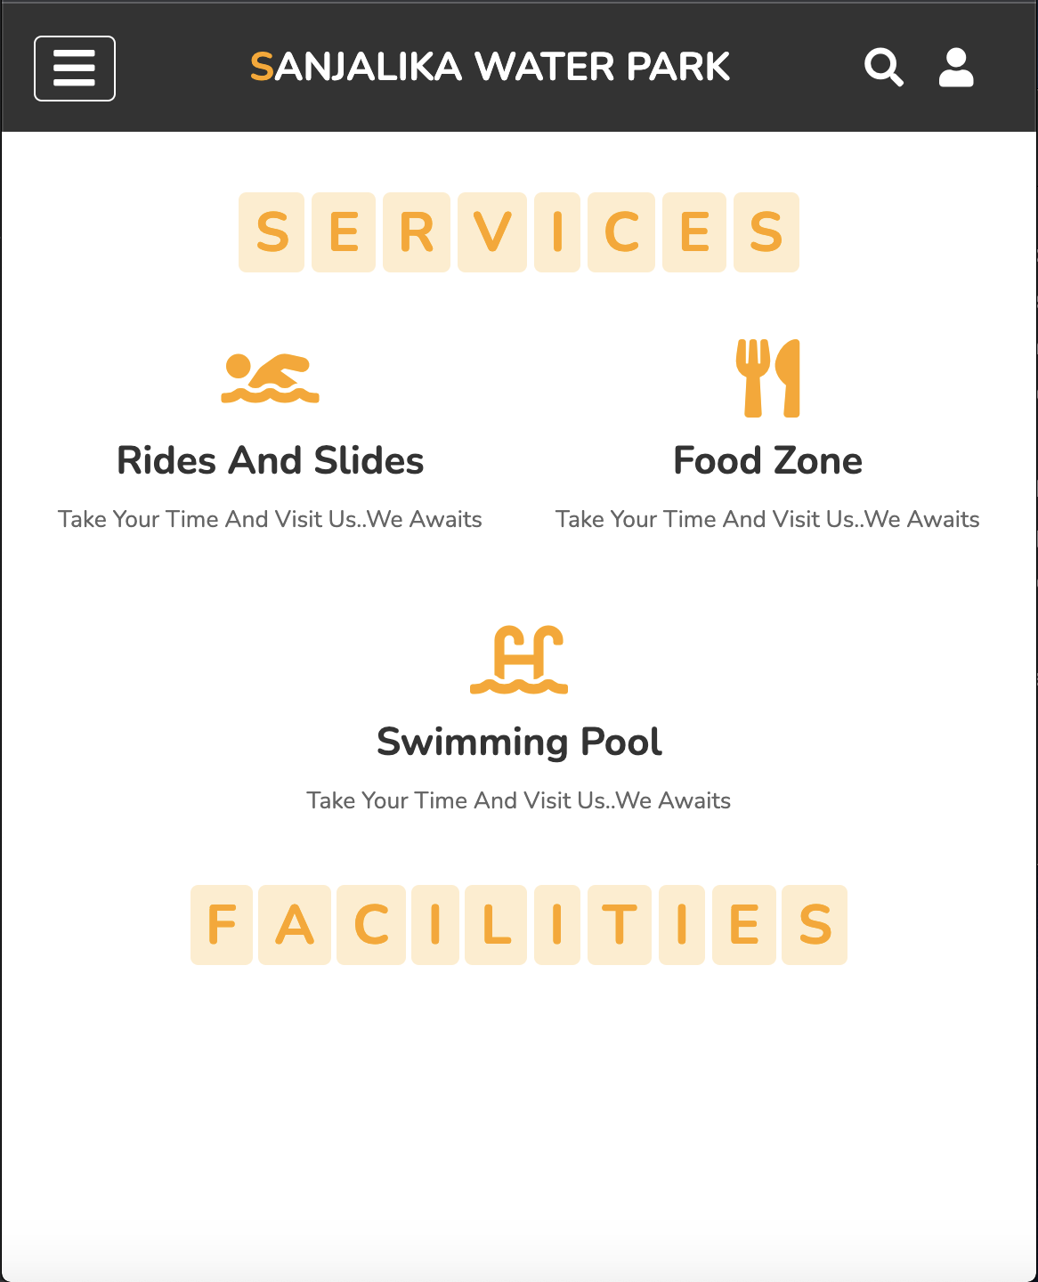

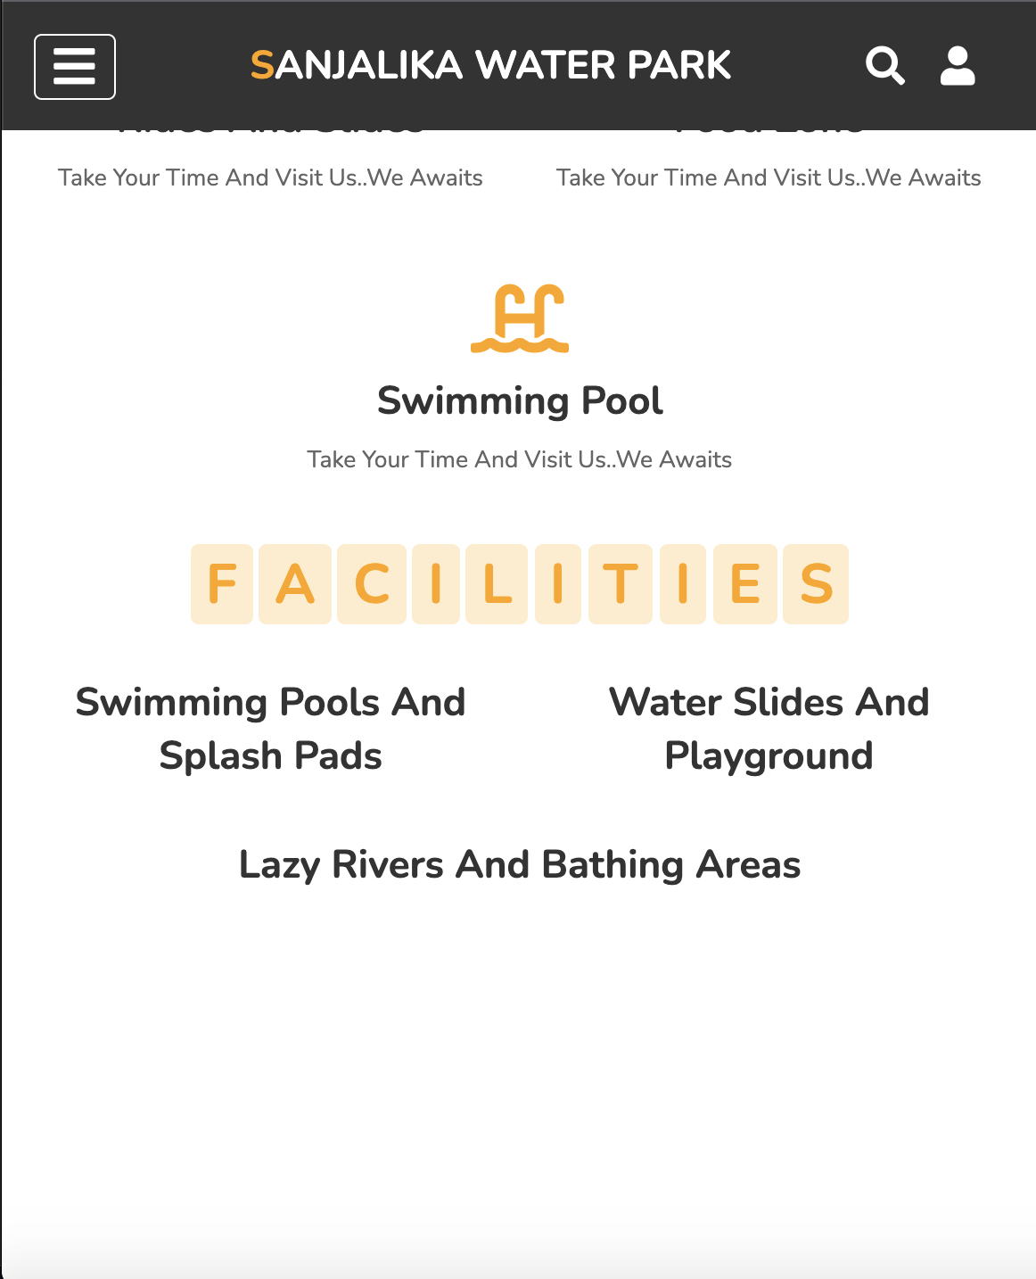

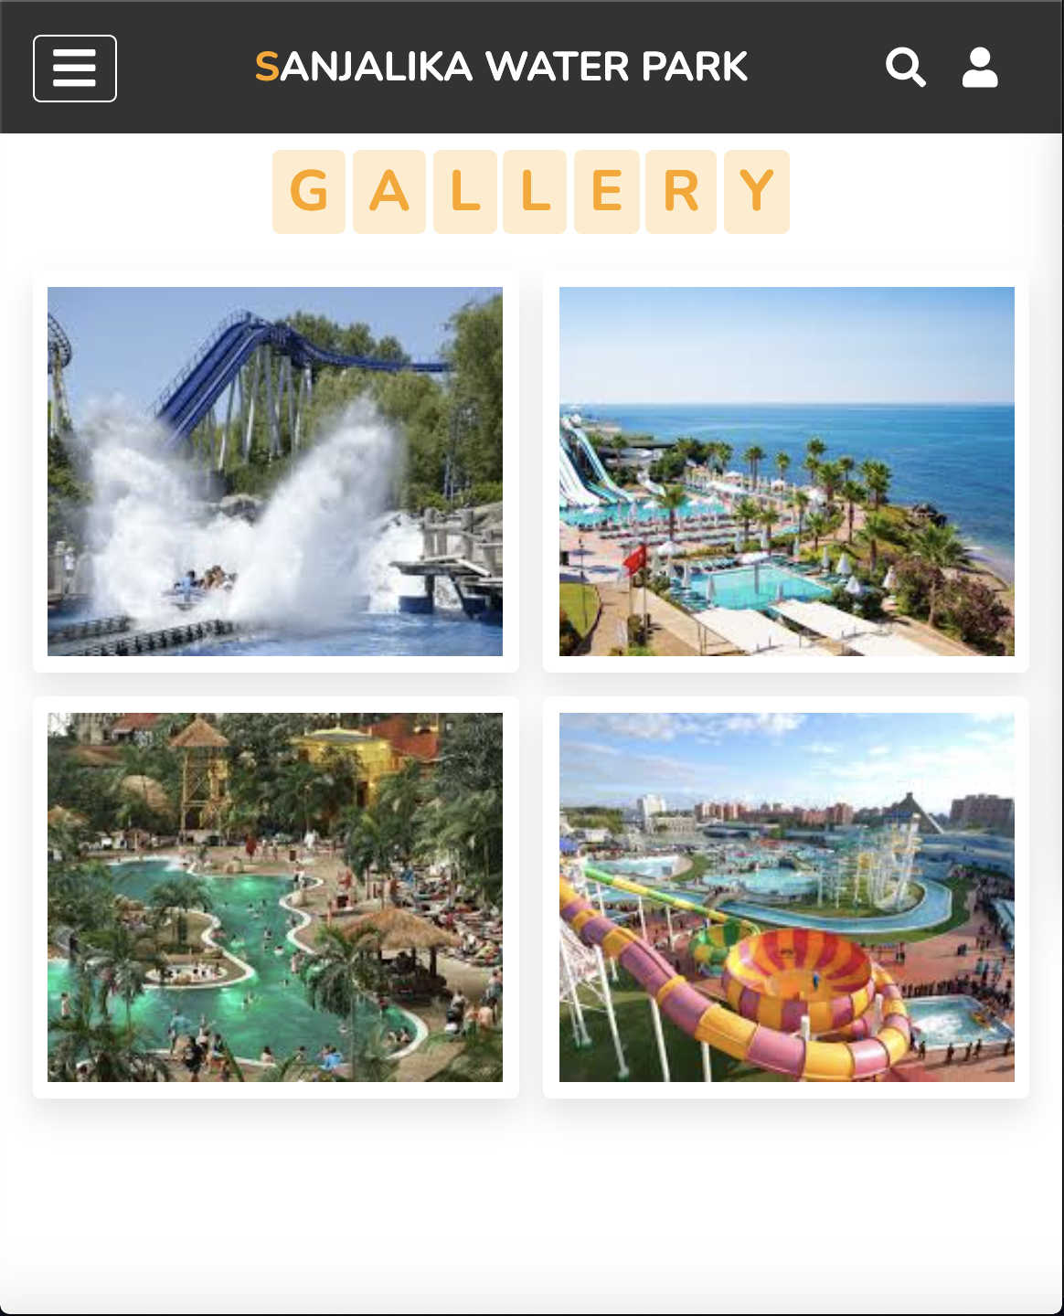



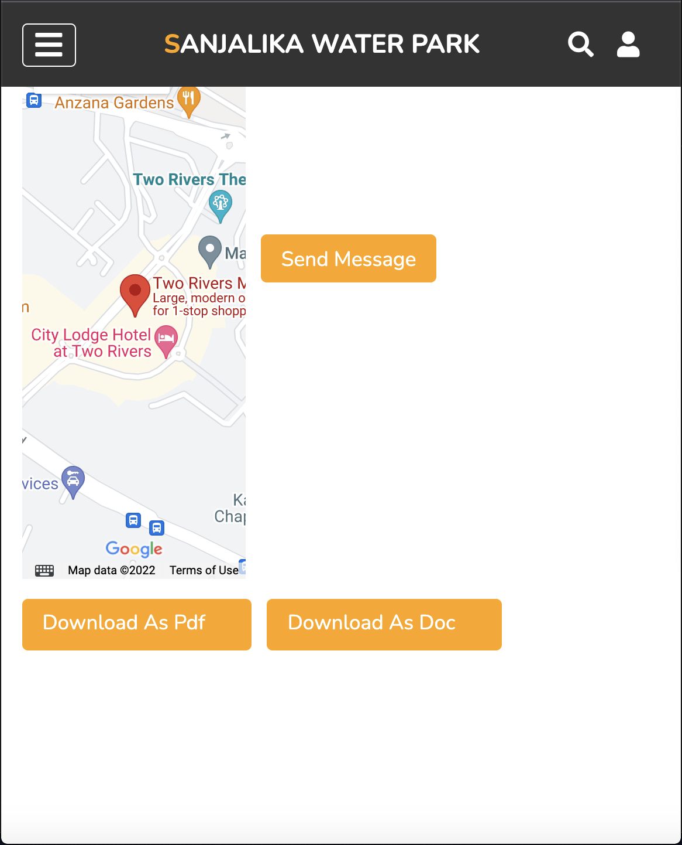

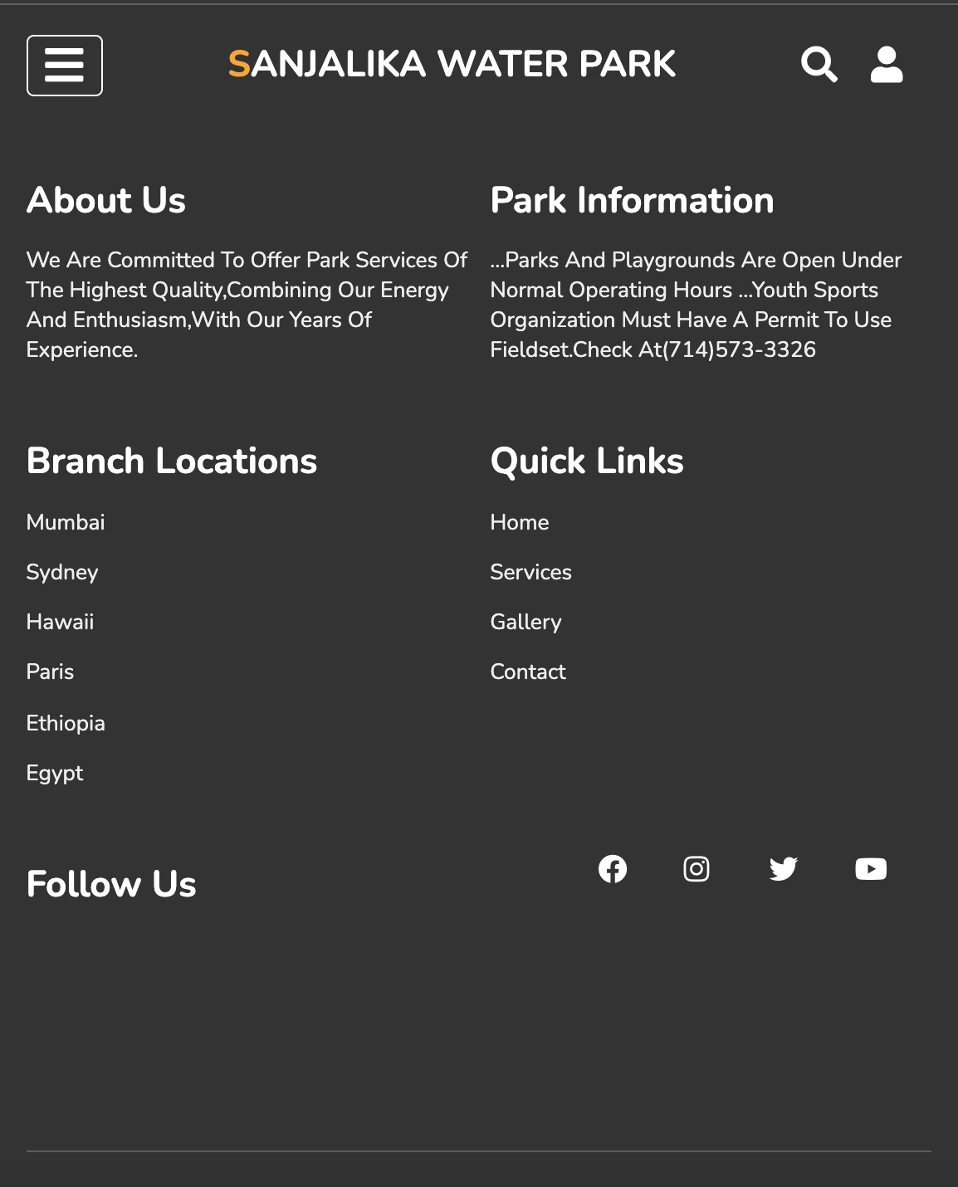

###### DEVELOPERS GUIDE

###### Index html code

<!DOCTYPE html>

<html lang="en">

<head>

<meta charset="UTF-8">

<meta name="viewport" content="width=device-width, initial-scale=1.0">

<title>SANJALIKA WATER PARK</title>

<!-- font awesome cdn link -->

<link rel="stylesheet" href="https://cdnjs.cloudflare.com/ajax/libs/font-awesome/5.15.4/css/all.min.css">

<!-- custom css file link -->

<link rel="stylesheet" href="https://unpkg.com/aos@next/dist/aos.css">

<link rel="stylesheet" href="style/style.css">

</head>

<body>

<!-- header section starts -->

<header>

<div id="menu-bar" class="fas fa-bars"></div>

<a href="#" class="logo"><span>S</span>anjalika water park</a>

<nav class="navbar">

<a href="#home">home</a>

<a href="#services">services</a>

<a href="#gallery">gallery</a>

<a href="#contact">contact</a>

</nav>

<div class="icons">

<i class="fas fa-search" id="search-btn"></i>

<i class="fas fa-user" id="login-btn"></i>

</div>

<form action="" class="search-bar-container">

<input type="search" id="search-bar" placeholder="search here...">

<label for="search-bar" class="fas fa-search"></label>

</form>

</header>

<!-- header section ends -->

<!-- login form container -->

<div class="login-form-container">

<i class="fas fa-times" id="form-close"></i>

<form action="">

<h3>login</h3>

<input type="email" class="box" placeholder="enter your email">

<input type="password" class="box" placeholder="enter your password">

<input type="submit" value="login now" class="btn">

<input type="checkbox" id="remember">

<label for="remember">remember me</label>

<p>forget password? <a href="#">click here</a></p>

<p>do not have an account? <a href="#">register now</a></p>

</form>

</div>

<!-- home section starts -->

<section class="home" id="home">

<div class="content">

<h3>enjoying is worthwhile</h3>

<p>we are committed to offer best services of the highest quality.</p>

<p>take your time and visit us..we awaits!!!</p>

<a href="#" class="btn">discover us more</a>

</div>

<div class="row">

<div class="two">

<h3>Working hours</h3>

<br>

<h5>Sunday : Closed</h5>

<h5>Monday - Friday<h5>

<p>7:00AM - 10:00PM</p>

</div>

<form action="">

<div class="inputBox">

<h3>where to</h3>

<input type="text" placeholder="place name">

</div>

<div class="inputBox">

<h3>how many</h3>

<input type="number" placeholder="number of guests">

</div>

<div class="inputBox">

<h3>arrivals</h3>

<input type="date">

</div>

<div class="inputBox">

<h3>leaving</h3>

<input type="date">

</div>

<input type="submit" class="btn" value="book now">

</form>

</div>

</section>

<!-- home section ends -->

<!-- services section starts -->

<section class="services" id="services">

<h1 class="heading" data-aos="fade-up">

<span>s</span>

<span>e</span>

<span>r</span>

<span>v</span>

<span>i</span>

<span>c</span>

<span>e</span>

<span>s</span>

</h1>

<div class="box-container">

<div class="box" data-aos="fade-up">

<i data-aos="fade-up" class="fas fa-swimmer"></i>

<h3 data-aos="fade-up">rides and slides</h3>

<p data-aos="fade-up">take your time and visit us..we awaits</p>

</div>

<div class="box" data-aos="fade-up">

<i data-aos="fade-up" class="fas fa-utensils"></i>

<h3 data-aos="fade-up">food zone</h3>

<p data-aos="fade-up">take your time and visit us..we awaits</p>

</div>

<div class="box" data-aos="fade-up">

<i data-aos="fade-up"class="fas fa-swimming-pool"></i>

<h3 data-aos="fade-up">swimming pool</h3>

<p data-aos="fade-up">take your time and visit us..we awaits</p>

</div>

</div>

<h1 class="heading" data-aos="fade-up">

<span>f</span>

<span>a</span>

<span>c</span>

<span>i</span>

<span>l</span>

<span>i</span>

<span>t</span>

<span>i</span>

<span>e</span>

<span>s</span>

</h1>

<div class="box-container">

<div class="box" data-aos="fade-up">

<h3 data-aos="fade-up">swimming pools and splash pads</h3>

</div>

<div class="box" data-aos="fade-up">

<h3 data-aos="fade-up">water slides and playground</h3>

</div>

<div class="box" data-aos="fade-up">

<h3 data-aos="fade-up">lazy rivers and bathing areas</h3>

</div>

</div>

</section>

<!-- services section ends -->

<!-- gallery section starts -->

<section class="gallery" id="gallery">

<h1 class="heading" data-aos="fade-up">

<span>g</span>

<span>a</span>

<span>l</span>

<span>l</span>

<span>e</span>

<span>r</span>

<span>y</span>

</h1>

<div class="box-container">

<div class="box" data-aos="fade-up">

<img src="images/a.jpg" alt="">

<div class="content">

<h3>amazing places</h3>

<p >take your time and visit us..we awaits</p>

<a href="#" class="btn">see more</a>

</div>

</div>

<div class="box" data-aos="fade-up">

<img src="images/b.jpg" alt="">

<div class="content">

<h3>amazing places</h3>

<p>take your time and visit us..we awaits</p>

<a href="#" class="btn">see more</a>

</div>

</div>

<div class="box" data-aos="fade-up">

<img src="images/c.jpg" alt="">

<div class="content">

<h3>amazing places</h3>

<p>take your time and visit us..we awaits</p>

<a href="#" class="btn">see more</a>

</div>

</div>

<div class="box" data-aos="fade-up">

<img src="images/d.jpg" alt="">

<div class="content">

<h3>amazing places</h3>

<p>take your time and visit us..we awaits</p>

<a href="#" class="btn">see more</a>

</div>

</div>

<div class="box" data-aos="fade-up">

<img src="images/e.jpg" alt="">

<div class="content">

<h3>amazing places</h3>

<p>take your time and visit us..we awaits</p>

<a href="#" class="btn">see more</a>

</div>

</div>

<div class="box" data-aos="fade-up">

<img src="images/f.jpg" alt="">

<div class="content">

<h3>amazing places</h3>

<p>take your time and visit us..we awaits</p>

<a href="#" class="btn">see more</a>

</div>

</div>

</div>

</section>

<!-- gallery section ends -->

<!-- contact section starts -->

<section class="contact" id="contact">

<h1 class="heading" data-aos="fade-up">

<span>c</span>

<span>o</span>

<span>n</span>

<span>t</span>

<span>a</span>

<span>c</span>

<span>t</span>

</h1>

<div class="row">

<div class="map" data-aos="fade-up">

<h2 data-aos="fade-up">Where you can find us</h2>

<p data-aos="fade-up"><i class="fa fa-map-marker" aria-hidden="true"></i>

120-240 nairobi</p>

<iframe src="https://www.google.com/maps/embed?pb=!1m18!1m12!1m3!1d3988.927522377504!2d36.79244811427434!3d-1.2107619358887693!2m3!1f0!2f0!3f0!3m2!1i1024!2i768!4f13.1!3m3!1m2!1s0x182f3d454886e4ab%3A0xc48e63a813496999!2sTwo%20Rivers%20Mall!5e0!3m2!1sen!2ske!4v1643293317651!5m2!1sen!2ske" width="600" height="450" style="border:0;" allowfullscreen="" loading="lazy"></iframe>

</div>

<form action="" data-aos="fade-up">

<a href="email/email.html">Send Message</a>

</form>

<script src="https://unpkg.com/swiper@7/swiper-bundle.min.js"></script>

<a data-aos="fade-up" href="sample.pdf" download class="download-btn">Download as pdf

<i data-aos="fade-up" class="fa fa-download"></i>

</a>

<a data-aos="fade-up" href="sample.doc" download class="download-btn">Download as doc

<i data-aos="fade-up" class="fa fa-download"></i>

</a>

</div>

</section>

<!-- contact section ends -->

<!-- footer section -->

<section class="footer" data-aos="fade-up">

<div class="box-container" data-aos="fade-up">

<div class="box" data-aos="fade-up">

<h3 data-aos="fade-up">about us</h3>

<p data-aos="fade-up">we are committed to offer park services of the highest quality,combining our energy and enthusiasm,with our years of experience.</p>

</div>

<div class="box" data-aos="fade-up">

<h3 data-aos="fade-up">park information</h3>

<p data-aos="fade-up">...parks and playgrounds are open under normal operating hours

...youth sports organization must have a permit to use fieldset.check at(714)573-3326

</p>

</div>

<div class="box" data-aos="fade-up">

<h3 data-aos="fade-up">branch locations</h3>

<a data-aos="fade-up" href="#">mumbai</a>

<a data-aos="fade-up" href="#">sydney</a>

<a data-aos="fade-up" href="#">hawaii</a>

<a data-aos="fade-up" href="#">paris</a>

<a data-aos="fade-up" href="#">ethiopia</a>

<a data-aos="fade-up" href="#">egypt</a>

</div>

<div class="box" data-aos="fade-up">

<h3 data-aos="fade-up">quick links</h3>

<a data-aos="fade-up" href="#">home</a>

<a data-aos="fade-up" href="#">services</a>

<a data-aos="fade-up" href="#">gallery</a>

<a data-aos="fade-up" href="#">contact</a>

</div>

<div class="box" data-aos="fade-up">

<h3 data-aos="fade-up">follow us</h3>

<a data-aos="fade-up" href="#">facebook</a>

<a data-aos="fade-up" href="#">instagram</a>

<a data-aos="fade-up" href="#">twitter</a>

<a data-aos="fade-up" href="#">youtube</a>

</div>

<div class="share">

<a data-aos="fade-up" href="#" class="fab fa-facebook"></a>

<a data-aos="fade-up" href="#" class="fab fa-instagram"></a>

<a data-aos="fade-up" href="#" class="fab fa-twitter"></a>

<a data-aos="fade-up" href="#" class="fab fa-youtube"></a>

</div>

</div>

<h1 class="credit">created by<span> ms.saliem tsegay</span></h1>

</section>

<script src="https://unpkg.com/aos@next/dist/aos.js"></script>

<script>

AOS.init({

offset:200,

duration:1000,

})

</script>

<!-- custom js file link -->

<script src="script/script.js"></script>

</body>

</html>

Index html style css

@import url('https://fonts.googleapis.com/css2?family=Nunito:wght@200;300;400;600;700&display=swap');

:root{

--orange:#ffa500;

}

*{

font-family: 'Nunito', sans-serif;

margin:0; padding:0;

box-sizing:border-box;

outline:none; border:none;

text-decoration:none;

text-transform:capitalize;

transition: all .2s linear;

}

*::selection{

background:var(--orange);

color:#fff;

}

html{

font-size:62.5%;

overflow-x:hidden;

scroll-padding-top: 6rem;

scroll-behavior: smooth;

}

section{

padding:2rem 9%;

}

.heading{

text-align:center;

padding:2.5rem 0;

}

.heading span{

background:rgba(255, 165, 0,.2);

font-size:3.5rem;

color:var(--orange);

border-radius:.5rem;

padding:.2rem 1rem;

}

.heading span.space{

background:none;

}

.btn{

background:var(--orange);

display:inline-block;

margin-top:1rem;

color:#fff;

padding:.8rem 3rem;

border:.2rem solid var(--orange);

cursor:pointer;

font-size:1.7rem;

}

.btn:hover{

background:rgba(255, 165, 0,.2);

color:var(--orange);

}

header{

position:fixed;

top:0; left:0; right:0;

background:#333;

display:flex;

align-items:center;

justify-content:space-between;

padding:2rem 9%;

z-index:1000;

}

header .logo{

font-size:2.5rem;

font-weight:bolder;

color:#fff;

text-transform:uppercase;

}

header .logo span{

color:var(--orange);

}

header .navbar a{

color:#fff;

font-size:2rem;

margin:0 .8rem;

}

header .navbar a:hover{

color:var(--orange);

}

header .icons i{

font-size:2.5rem;

color:#fff;

cursor:pointer;

margin-right: 2rem;

}

header .icons i:hover{

color:var(--orange);

}

header .search-bar-container{

position:absolute;

top:100%; left:0; right:0;

background:#333;

padding:1.5rem 2rem;

border-top: .1rem solid rgba(255,255,255,.2);

display:flex;

align-items:center;

z-index:1001;

clip-path: polygon(0 0, 100% 0, 100% 0, 0 0);

}

header .search-bar-container.active{

clip-path: polygon(0 0, 100% 0, 100% 100%, 0 100%);

}

header .search-bar-container #search-bar{

width:100%;

padding:1rem;

text-transform:none;

color:#333;

font-size:1.7rem;

border-radius: .5rem;

}

header .search-bar-container label{

color: #fff;

cursor: pointer;

font-size: 3rem;

margin-left: 1.5rem;

}

header .search-bar-container label:hover{

color: var(--orange);

}

.login-form-container{

position:fixed;

top:-120%; left:0;

z-index:10000;

min-height:100vh;

width:100%;

background:rgba(0,0,0,.7);

display:flex;

align-items:center;

justify-content: center;

}

.login-form-container.active{

top:0;

}

.login-form-container form{

margin:2rem;

padding:1.5rem 2rem;

border-radius: .5rem;

background:#fff;

width:50rem;

}

.login-form-container form h3{

font-size:3rem;

padding:1rem 0;

color:#444;

text-transform: uppercase;

text-align:center;

}

.login-form-container form .box{

width:100%;

font-size:1.7rem;

padding:1rem;

color:#333;

margin:.6rem 0;

border:.1rem solid rgba(0,0,0,.3);

text-transform: none;

}

.login-form-container form .box:focus{

border-color:var(--orange);

}

.login-form-container form #remember{

margin:2rem 0;

}

.login-form-container form label{

font-size:1.5rem;

}

.login-form-container form .btn{

display:block;

width:100%;

}

.login-form-container form p{

padding:.5rem 0;

font-size:1.5rem;

color:#666;

}

.login-form-container form p a{

color: var(--orange);

}

.login-form-container form p a:hover{

color:#333;

text-decoration:underline;

}

.login-form-container #form-close{

color:#fff;

position:absolute;

top:2rem; right:3rem;

font-size:5rem;

cursor:pointer;

}

#menu-bar{

color:#fff;

border:.1rem solid #fff;

border-radius: .5rem;

font-size:3rem;

cursor:pointer;

padding:.5rem 1.2rem;

display:none;

}

.home{

display:flex;

align-items:center;

justify-content:center;

flex-flow:column;

z-index:0;

min-height:100vh;

position:relative;

background:url(background.jpg);

background-size:cover;

background-position:center;

}

.home .box{

width:300px;

height:400px;

padding:0;

margin:100px auto;

color: var(--orange);

}

.home .content{

text-align:center;

}

.home .content h3{

font-size:4.5rem;

color:var(--orange);

text-transform:uppercase;

text-shadow: 0 .3rem .5rem rgba(0,0,0,.1);

padding-bottom:0.2rem;

}

.home .content p{

font-size:2.5rem;

color:var(--orange);

padding: .5rem 0;

}

.home .row{

display: flex;

flex-wrap: wrap;

gap:1.5rem;

align-items:center;

}

.home .row form{

display: grid;

grid-template-columns: repeat(2, 1fr);

padding:10rem;

padding-top:0;

padding-bottom:0;

padding-right:2rem;

box-shadow:0 1rem 2rem rgba(0,0,0,.1);

border-radius: .5rem;

color:var(--orange);

}

.home .row form .inputBox input{

width:100%;

padding:1rem;

border:.1rem solid rgba(0,0,0,.1);

font-size:1.7rem;

color:var(--orange);

text-transform:none;

}

.home .row form .inputBox h3{

font-size:2rem;

padding:1rem 0;

color:#666262;

}

.home .two{

width: 25%;

border-right: 3px solid #666262;

padding-left: 4rem;

}

.home .two h3{

font-size: 2.9rem;

color:#666262;

padding-top:0;

}

.home .two h5{

font-size:2rem;

color:#666262;

}

.home .two p{

font-size: 1.8rem;

color: #666262;

margin-bottom: 0.8rem;

}

.services .box-container{

display:flex;

flex-wrap:wrap;

gap:1.5rem;

}

.services .box-container .box{

flex:1 1 30rem;

border-radius: .5rem;

padding:1rem;

text-align:center;

}

.services .box-container .box i{

font-size:5rem;

padding:1rem;

color:var(--orange);

}

.services .box-container .box h3{

font-size:2.5rem;

color:#333;

}

.services .box-container .box p{

font-size:1.5rem;

color:#666;

padding:1rem 0;

}

.services .box-container .box:hover{

box-shadow:0 1rem 2rem rgba(0,0,0,.1);

}

.gallery .box-container{

display:flex;

flex-wrap:wrap;

gap:1.5rem;

}

.gallery .box-container .box{

overflow:hidden;

box-shadow:0 1rem 2rem rgba(0,0,0,.1);

border:1rem solid #fff;

flex:1 1 30rem;

border-radius: .5rem;

height:25rem;

position:relative;

}

.gallery .box-container .box img{

height:100%;

width:100%;

object-fit:cover;

}

.gallery .box-container .box .content{

position:absolute;

top:-100%; left:0;

height:100%;

width:100%;

text-align:center;

background:rgba(0,0,0,.7);

padding:2rem;

padding-top: 5rem;

}

.gallery .box-container .box .content h3{

font-size:2.5rem;

color:var(--orange);

}

.gallery .box-container .box .content p{

font-size:1.5rem;

color:#eee;

padding:.5rem 0;

}

.gallery .box-container .box:hover .content{

top:0;

}

.contact .row{

display:flex;

flex-wrap:wrap;

gap:1.5rem;

align-items:center;

}

.contact .row form a{

background-color:var(--orange);

color:white;

padding:1rem 2rem;

font-size:2rem;

text-decoration:none;

border-radius:5px;

height:5rem;

}

.contact .row form a:hover{

background-color:#333;

}

.contact .map{

width: 35%;

}

.contact .map h2{

font-size: 2rem;

color: #212529;

padding-bottom: 10px;

width: 100%;

}

.contact .map p{

font-size: 1.1rem;

color: #212529;

padding-bottom: 30px;

width: 100%;

}

.contact .map p i{

color: red;

padding-right: 4px;

}

.contact .map iframe{

width: 100%;

}

.footer{

background:#333;

}

.footer .box-container{

display:flex;

flex-wrap:wrap;

gap:1.5rem;

}

.footer .box-container .box{

padding:1rem 0;

flex:1 1 25rem;

}

.footer .box-container .box h3{

font-size:2.5rem;

padding:.7rem 0;

color:#fff;

}

.footer .box-container .box p{

font-size:1.5rem;

padding:.7rem 0;

color:#eee;

}

.footer .box-container .box a{

display:block;

font-size:1.5rem;

padding:.7rem 0;

color:#eee;

}

.footer .box-container .box a:hover{

color:var(--orange);

text-decoration:underline;

}

.footer .credit{

text-align:center;

padding:2rem 1rem;

margin-top:1rem;

font-size:2rem;

font-weight:normal;

color:#fff;

border-top: .1rem solid rgba(255,255,255,.2);

}

.footer .credit span{

color:var(--orange);

}

.footer .share{

padding:1rem 0;

}

.footer .share a{

height:5rem;

width:5rem;

font-size:2rem;

color:#fff;

margin:.3rem;

}

.footer .share a:hover{

color:var(--orange);

padding:1rem 1rem;

}

.download-btn{

background-color:var(--orange);

color:white;

padding:1rem 2rem;

font-size:2rem;

text-decoration:none;

border-radius:5px;

height:5rem;

}

.download-btn:hover {

background-color:#333;

}

/* media queries */

@media (max-width:1200px){

html{

font-size:55%;

}

}

@media (max-width:991px){

header{

padding:2rem;

}

section{

padding:2rem;

}

}

@media (max-width:768px){

#menu-bar{

display:initial;

}

header .navbar{

position:absolute;

top:100%; right:0; left:0;

background:#333;

border-top: .1rem solid rgba(255,255,255,.2);

padding:1rem 2rem;

clip-path:polygon(0 0, 100% 0, 100% 0, 0 0);

}

header .navbar.active{

clip-path:polygon(0 0, 100% 0, 100% 100%, 0 100%);

}

header .navbar a{

background:#222;

display:block;

border-radius: .5rem;

padding:1.5rem;

margin:1.5rem 0;

}

}

@media (max-width:450px){

html{

font-size:50%;

}

}

Script file

let searchBtn = document.querySelector('#search-btn');

let searchBar = document.querySelector('.search-bar-container');

let formBtn = document.querySelector('#login-btn');

let loginForm = document.querySelector('.login-form-container');

let formClose = document.querySelector('#form-close');

let menu = document.querySelector('#menu-bar');

let navbar = document.querySelector('.navbar');

window.onscroll = () =>{

searchBtn.classList.remove('fa-times');

searchBar.classList.remove('active');

menu.classList.remove('fa-times');

navbar.classList.remove('active');

loginForm.classList.remove('active');

}

menu.addEventListener('click', () =>{

menu.classList.toggle('fa-times');

navbar.classList.toggle('active');

});

searchBtn.addEventListener('click', () =>{

searchBtn.classList.toggle('fa-times');

searchBar.classList.toggle('active');

});

formBtn.addEventListener('click', () =>{

loginForm.classList.add('active');

});

formClose.addEventListener('click', () =>{

loginForm.classList.remove('active');

});

Email html

<!DOCTYPE html>

<html>

<head>

<title>contact</title>

<link rel="stylesheet" href="style.css">

</head>

<body style = "background: var(--orange)">

<div class="contact-box">

<form>

<input type="text" class="input-field" placeholder="Your Name">

<input type="email" class="input-field" placeholder="Your Email">

<input type="text" class="input-field" placeholder="Subject">

<textarea type="text" class="input-field textarea-field" placeholder="Your Meassage">

</textarea>

<button type="button" class="btn">Send Message</button>

</form>

</div>

</body>

</html>

Email css

*

{

margin: 0;

padding: 0;

}

body

{

background-color: #efefef;

font-family: sans-serif;

}

.contact-box

{

width: 500px;

background-color: #fff;

box-shadow: 0 0 20px 0 #999;

top: 50%;

left: 50%;

transform: translate(-50%,-50%);

position: absolute;

}

form

{

margin: 35px;

}

.input-field

{

width: 400px;

height: 40px;

margin-top: 20px;

padding-left: 10px;

padding-right: 10px;

border: 1px solid #777;

border-radius: 14px;

outline: none;

}

.textarea-field

{

height: 150px;

padding-top: 10px;

}

.btn

{

border-radius: 20px;

color: #fff;

margin-top: 18px;

padding: 10px;

background-color: #47c35a;

font-size: 12px;

border: none;

cursor: pointer;

}